

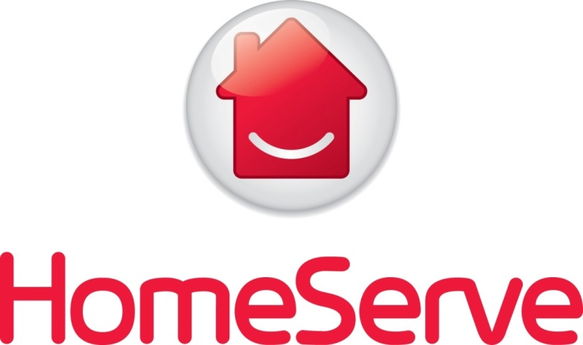

**Unity Programme**

**UK Release 6**

**Sprint 4**

**MDM Real-Time Integration**

**Technical Design**

**Version 3.0**

Table of Contents

1 Introduction 4

1.1 MDM Platform Overview 4

1.2 Objective 5

1.3 Distribution List 5

1.4 Glossary 6

2 Technical Design 7

2.1 Requirements Overview 7

2.2 High Level Component and Dataflow 10

2.3 Design Requirements 11

2.3.1 Data Validation and Business Rules 12

2.3.2 Design Decisions 13

2.4 Assumptions 17

Note: Please refer ICD document sec 4.1.2 for more assumptions 19

2.5 Risks 19

2.6 Issues 20

2.7 Interface Details 20

2.7.1 Interface Specification Details 20

2.7.2 Interface Frequency and Schedule 20

2.8 Flowcharts 20

2.8.1 Create Party Service 20

2.8.2 Update Party Service 21

2.8.3 Get Party Details Service 23

2.8.4 Get DocumentDetails Service: 24

2.8.5 Get Campaigns Service 25

2.8.6 GetAccountContractDocument Service 26

2.8.7 Search Party Service 27

2.8.8 Manage Customer Account Service 28

2.8.9 ManageDocumentDetails Service 29

2.9 MDM Data Model 30

2.9.1 Entity Description 30

2.9.2 Reference Dataset 31

2.10 Mapping and Transformation Rules 32

2.11 Technical Component Details 33

3 Non-Functional Design 36

3.1 Security and Data Access 36

3.2 Performance Considerations 36

3.3 Deployment, Scheduling & Notification 37

3.4 Error Handling and Fault Management 37

3.5 Housekeeping Policies 39

4 Appendix 41

4.1 References 41

4.1.1 Ensura – Business Rules Presentation: 41

4.1.2 Real time Interface Contract Document (ICD) 41

4.1.3 MDM Platform Design 41

4.1.4 Reference Dataset 41

4.1.5 Unity Error Catalogue: 41

4.1.6 Ensura Duplicate Customer Check Requirement Document 41

4.1.7 Pega Business Rules for R1 42

4.1.8 Duplicate Cover Check Design Document 42

4.1.9 Ensura – INT32,33 Small Change Document (BRD) for Release 4 42

4.1.10 Review Comments 42

4.1.11 BBDM CR241 related artifacts 42

4.1.12 CR 305 Details 43

**Document Maintenance**

***Document Owners***

|  |  |
| --- | --- |
| Functional owner(s):Naveen Mula, Mohamed Fahmy | |
| Technical Owner(s): Venkata Samavedam | |
| Current Version: | 3.0 |
| Date Last Updated: | 25st Sep 2017 |

***Version Control***

|  |  |  |  |
| --- | --- | --- | --- |
| Version | Date Updated | Revision Author | Summary of Major Changes Made |
| 0.1 | 19/09/2014 | Vinoth / Mohini | Initial Draft |
| 0.2 | 23/09/2014 | Sekhar | Added flowcharts for all the services |
| 0.3 | 26/09/2014 | Vinoth | Reviewed and updated the entire document. |
| 0.4 | 02/10/2014 | Vinoth Srinivasan | Updated the document based on the review comments from Homeserve Architecture team and Stanley Bode |
| 0.5 | 13/10/2014 | Vinoth Srinivasan | Updated the document based on review comments from Steve Dyer. |
| 0.6 | 05/06/2015 | Sekhar Karnat | Updated as per the R4 requirement and also new attributes added. |
| 0.7 | 24/06/2015 | Narayana Velaga | Updated Assumptions & Design decisions |
| 0.8 | 04/01/2016 | Sekhar Karnat | Updated error codes and |
| 0.9 | 13/01/2016 | Chethana | Including document details related design decisions and assumptions |
| 1.0 | 24/02/2016 | Chethana | Data model changes and wsdl changes for create/update/get/search are included |
| 1.1 | 07/03/2016 | Kosala Ranatunga | Updated as per the decision to get the UpdateParty service requests from both Alfresco and PEGA |
| 1.2 | 26/05/2016 | Sekhar Karnat/Chethana | Updated as per the R6 requirement |
| 1.3 | 07/06/2016 | Sekhar Karnat | Added CustomerAccount level document details. |
| 1.4 | 9th June 2016 | Ashok Vemula | Added Review comments from Mark Buck |
| 1.5 | 15th June 2016 | Sekhar Karnat | Updated the MCA Services WSDL as per Mark’s comments (Removed Complex Type) |
| 1.6 | 8th Aug 2016 | Chethana | Updated document according to the latest data model |
| 1.7 | 12th Aug 2016 | Chethana | Introduced R6 Sprint 3 changes including changes to GetPartyService |
| 1.8 | 26th Aug 2016 | Chethana | Introduced document structure and a new operation for ManageDocumentDetails to support ESB in storing document details |
| 1.9 | 16th Sep 2016 | Chethana | Updated CreatePartyService to support Affinity Prospects to convert to e-serve prospect/customer |
| 2.0 | 21st Sep 2016 | Ashok Vemula | Removed Partner Option code from Manage Customer Account WSDL, As part of Multi partner/Underwriter/ Excess changes |
| 2.1 | 10th Oct 2016 | Manoj Kumar | Added Search Party changes as part of R6 Sprint 3. |
| 2.2 | 18th Oct 2016 | Chethana | Includes Changing schema of Document and related table |
| 2.3 | 25th Nov 2016 | Chethana | Including new calling system CTI under CR 325 and JAH Incident related WSDL changes. |
| 2.4 | 28th Nov 2016 | Sravani | Updated with Release6.4 Drop1 Requirements. New column DocumentFormat column is added to Document object. |
| 2.5 | 8th Dec 2016 | Rajesh Srinivasulu | Incorporated changes for CR241 as part of R6.4 (BBDM release). Refer the section 2.1, 2.3.2, 2.4, 2.9, 2.10 and 4.1.11 for updates. |
| 2.6 | 19-Dec-2016 | Rajesh Srinivasulu | Incorporated the review comments from Mark Buck for CR241 i.e. Added MDMAddressID in GetParty response.  Refer sections 2.4 & 2.10 for updates. |
| 2.7 | 31-Jan-2017 | Venkata S | Updated IDD with Marketing Campaign requirements. |
| 2.8 | 28-Feb-2017 | Chethana | Updated IDD with GWA requirement |
| 2.9 | 01-Mar-2017 | Chethana | Duplicate Cover Requirements |
| 2.10 | 20-Mar-2017 | Venkata S | Provided reply to reviewer comments. |
| 3.0 | 25th Sep 2017 | Ashok V | Updated GetParty service to support web as a valid calling source system |
| 3.1 | 30th April 2018 | Ashok V | [**R6.4 Retrofit**]: Updated MDD operation to leverage CustomerAccount, contract ID validation which will allow eServe to store the noncustomer documents in MDM as a defect fix QC14706. |

**Note:** These documents are strictly for specific Virtusa/HomeServe use only. They shall not be shared with an external party other than HomeServe. These documents should always be kept securely and employees shall use reasonable care protecting these documents from unauthorized use or disclosure to a third party. This category also covers client intellectual property where Virtusa has a non-disclosure agreement with HomeServe.

**Document Approval**

Virtusa Corporation and HomeServe have reviewed this document and hereby agree that the contents herein are accurate. Any changes to this document must be communicated in writing and signed-off by both parties.

|  |  |
| --- | --- |
| Signature | Signature |
| Date: | Date: |
| Name: | Name: |
| Client:: HomeServe | Virtusa Corporation |
| Address:  Cable Drive,  Walsall,  West Midlands  WS2 7BN | Address:  **Virtusa (UK) Ltd**  Level 8  26 Finsbury Square London EC2A 1D  E-mail: [info@virtusa.com](mailto:Info@techprov.com)  URL: [www.virtusa.com](http://www.techprov.com) |

# Introduction

## MDM Platform Overview

HomeServe is looking to transform its customer experience by moving to customer centric stack through Unity Programme. Key Objectives of the programme are,

* Transform into a customer-centric business, efficiently offering right product mix via multiple digital channels
* Grow by reducing cycle time to launch new products and integrating new partners
* Engage with customers via the channel they desire and the right product, with a single customer ‘account’

Master Data Management (MDM) comprises the processes, governance, policies, standards and tools that consistently define and manage the critical data of an organization to provide a single point of reference.

In HomeServe, the strategic platform is using MDM system to consolidate the customer/prospect information from various source systems for operational and marketing use. The following diagram outlines the overall MDM Platform architecture.



**CTI**

New calling system

**This technical design document covers the MDM and Pega/Ensura/Alfresco Real Time integration mechanism and Updates for Release 5 highlighted in red border line in the above diagram**

There are Real time services that are delivered in the previous releases of Unity Programme for Manage Party information in MDM as indicated below

Services,

* Create Party Service
* Update Party Service
* Get Party Service
* GetDocumentDetails Service
* Search Party Service
* Manage Customer Account Service
* ManageDocumentDetails Service
* Duplicate Customer Check Service

As part of the current release the PEGA & Ensura use the above services and needs enhanced except Duplicate Customer Check. Duplicate Cover Check is another service that is build and will be covered in other document. Please refer Appendix for more details

## Objective

This technical design outlines the integration of core customer/prospect details from Ensura/Pega to MDM in Realtime for Unity Programme (UK – R6). Key objectives of this technical design document is to cover the following items to support the construction phase,

1. High level data integration flow
2. Design Decisions
3. Assumptions
4. Physical MDM Data Model
5. Mapping specifications
6. Non-functional designs

## Distribution List

Approval List

|  |  |  |
| --- | --- | --- |
| **Name** | **Organization** | **Role** |
| Shafiq Ratansi | HomeServe | Senior Design Architect |
| Mark Buck | HomeServe | Solution Architect |

Discussion / Review List

In addition to those on the approval list above comments will be sought from the following people/groups.

|  |  |  |
| --- | --- | --- |
| **Name** | **Organization** | **Role** |
| Manu Swami | Virtusa | Data Head |
| Mohamed Fahmy | Virtusa | Data Architect |
| Naveen Mula | Virtusa | Lead Data Architect |
| Rajani Dumpa | Virtusa | Data Architect |

Governance

|  |  |  |
| --- | --- | --- |
| **Name** | **Applicable?** | **Approval Details** |
| Technical Design Authority | Y |  |
| Business Design Authority | N | NA |

## Glossary

|  |  |
| --- | --- |
| **Term** | **Definition** |
| MDM | Master Data Management |
| SOAP | Simple Object Access Protocol |
| XML | eXtended Markup Language |
| WSDL | Web Services Description Language |
| SAM | Service Activity Monitoring |
| TAC | Talend Administrator Centre |
| CA | Customer Account |
| JA | Joint Account |
| JAH | Joint Account Holder |
| ToC | Transfer of Cover |
| DCC | Duplicate Cover Check |
| AP | Authorised Party |
| SPS | Search Party Service |
| GPS | Get Party Service |
| CPS | Create Party Service |
| UPS | Update Party Service |
| MCAS | Manage Customer Account Service |
| MDDS | Manage Document Details Service |
| CTI | Computer Telephony Integration |
| BBDM | Back Book Data Migration |

# Technical Design

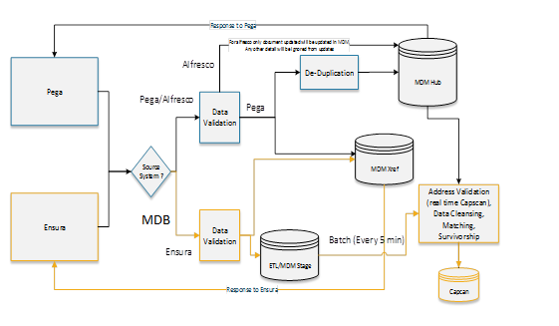

Search for details of all the systems

Response to CTI

CTI

MBD

Note: Flow highlighted in blue is for PEGA , yellow is for Ensura process flow and Green is for CTI flow

## Requirements Overview

There will be a capability in R4 for source systems to check the existence of customer/cover before selling a contract (policy). Hence MDM system should be integrated both Pega/Ensura for Party details to be replicated in real-time to deliver the required capability from MDM. Furthermore MDM will accept document details from Alfresco through the UpdateParty service. These document details will be stored as Party level documents or Contract level documents.

The SharePoint links about the requirements delivered for PEGA integration from R1 are given in the Section 4.1. The existing services needs to be extended to support the duplicate cover check functionality along with storing the product mapping information in MDM. Please refer to Section 4.1 for more details about the interfaces

As part of Release 6 Sprint 2, MDM will store the Joint Customer Account information in MDM through real-time services coming from Pega.

As part of Release 6 Sprint 3, MDM returns only required details to the calling system with in NFR boundaries using GetDocumentDetails

A new operation ManageDocumentDetails is designed to ManageCustomerAccountService(MCA) such that the existing service is not impacted functionally and the new operation supports ESB in storing document details in MDM.

CreateParty Service is updated to support the Affinity Partner prospect to be converted as a customer/prospect by e-serve.

SearchPartyService is updated to support CTI calling system to return all the customer/prospect details based on the request

**Release 6, Sprint 4:**

As part of Release 6 Sprint 4 (BBDM release), MDM will start receiving the Ensura migrated customers / contracts details from eServer system. These MDM changes are specific to the BBDM CR241 mentioned below.

***CR241 - Change Description:***

* **Include MDM Party ID in the Create Party Service.** When data is passed to eServe, as part of the Data Migration Solution, it should include the MDM Party ID (if available; i.e. optionally) for the customer. Once the Create Party Service has successfully created the record (as part of the Migration Execute Sale), it should pass the MDM Party ID back to MDM so to enable MDM to “link” the Ensura records with the eServe records in MDM. Irrespective of whether a Contract or Quote is created as part of the migration, solution should attempt to link Ensura and eServe records in MDM.
* **Add Migration Flag in Party (Customer) and Contract entities in MDM and manage values for them rules based on the business rules.** MDM should capture migration level markers from Ensura system for the contracts and customers which create a provision that can be used by external systems to determine where in the migration process a customer/policy is (from Ensura to eServe).

Refer section 4.1.11 for CR document.

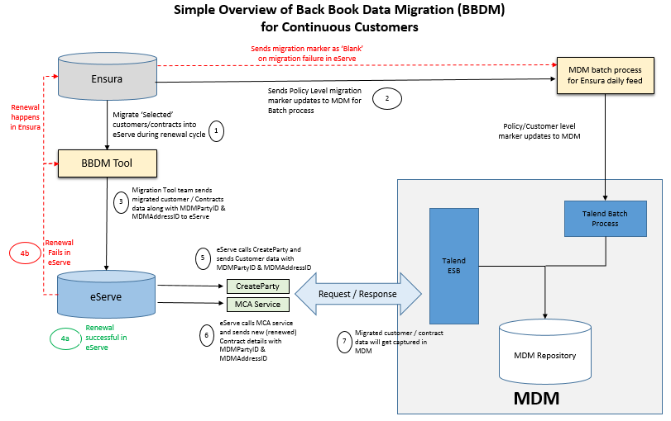

As Part of Release 6.4, In Addition to existing document object, new column Document format is added to store format of document from GMC. From Customer 360 view documents will be displayed along with metadata in which format document has sent to customers. Below are list of services which gets impacted due to this requirement.

1. ManageCustomerAccount Service operation MDD (Manage Document Details)
2. Create and Update Party Services
3. GetParty Service

**Requirement No 01886:**

As Part of Release 6.4 Marketing Campaigns requirements, Campaigns details are shown in eServe customer 360. From Customer 360, eServe makes a call to MDM service to get all campaign IDs associated to Party. In response, MDM will return the campaign IDs and eServe will populate other campaign details by fetching form eServe database then display the details in 360. To support this functionality MDM will provide new operation and do changes to existing operations. Below are list of services which gets impacted due to this requirement.

1. GetParty Service New Operation – GetCampaigns
2. Changes to existing Getparty Operation to add campaigns details in response.

**R6.4 Sprint 4 Duplicate Cover, Renewals Requirements and CTI requirements:**

As part of R6.4 eServe enhanced its functionality to reinstate cancelled and expired contacts within 28days and 60days from date of cancellation and expiry respectively. Due to this change eServe cancelled and expired contracts will be treated as “Active” from external system point of view. Below are list of impacted MDM services.

As party of CTI Acquisition via Dialer requirements, SSID needs to be added at party level in search party response to identify source of party when multiple prospects are return when do search by telephone number.

* SearchPartyService Changes:
* Added SSID in search party response WSDL
* Database view level, include “Cancelled” and “Expired” eServe contract status in the Active contract list.

**R6.4 Sprint 4 GWA Requirements R_1899 and R_1900:** eServe creates case against Contract and associates the CaseID with Party Enquiry document and send it to Alfresco and MDM. From 360 CSR will be able to see these documents in Inbound Correspondence tab and GWA screens.

In order to support this feature in eServe, MDM enhanced the existing GetDocumentDetails in GetPartyService and ManageDocumentDetails operation in MCAService.

1. **ManagementDocumentDetails:** Add CaseID as optional field in Document Object. If its enquiry document against a Contract then only CaseID will be populated else it will be blank.
2. **GetDocumentDetails:** Add optional field CaseID in request and response structures.

From 360, Enquiry document will be available in InboundCorrespondance tab and in GWA screen, when CSR clicks on the CaseID(Pre-populated from eServe databse) then internally eServe calls GetDocumentDetails with SourceCustomerID and CaseID to fetch enquiry related document.

**Release 6, Sprint 4.1:**

In an effort to provide self-service journey to the customers, HomeServe DTS team will use MDM get party service to support eDocs functionality via ESB.

Below are the high level changes as a part of Release 6 Sprint 4.1

* Going forward MDM GetParty Service will support Calls from Web.

## High Level Component and Dataflow

The following diagram explains the high level component and dataflow of Pega/Ensura and MDM integration.



MDM will expose CreateParty, UpdateParty, GetParty, SearchParty and ManageCustomerAccount Realtime services to calling systems via Talend ESB. Pega, Ensura and Alfresco will consume these services in Realtime. Further processing to MDM will be different for each system and the details of the load will be discussed in the later sections

Talend ESB receives the request message and authenticates using http username/password mechanism. The authenticated request message will be validated and business rules and transformation logics will be applied and loaded onto MDM database. Then response message will be constructed and sent to the calling system via Talend ESB layer.

Ensura response will be constructed with xref key(xref_party_id) once loaded data into cross reference and ETL/MDM staging tables. Data will be loaded from staging to MDM by using batch process (every 5 min) after data cleansing, matching and survivorship rules.

CTI hits SearchPartyService to retrieve the customer/prospect details irrelevant to source systems

Note: ManagerCustomerAccount service will only be consumed by Pega. ManageDocumentDetails will be consumed only by Alfresco

## Design Requirements

Below are the new requirements for Release 4 for loading the data from Ensura

* Integrate Ensura in Near Real time
* Implement the below Business Rules that are implemented in the Ensura daily batch process
  + Address Validation with Real time Capscan Matchcode
  + Email Cleansing
  + Telephone Cleansing
  + Customer Matching
  + Survivorship

Address Validation for Ensura data will be processed using Real time Capscan and will not require any MoveIT process. Result from Capscan will be loaded to Staging Output if response is a perfect match else address from the request will be loaded without a PAF Key.

There is a process of cleansing the PAF Invalid addresses in MDM that will still continue along with data exception reports in place.

Details about the Technical design & business rules implemented for Ensura Batch process in the link: [Ensura Batch Design](https://serveusa.sharepoint.com/sites/HomeServe/GlobalResources/GlobalProjects/Ensura/_layouts/15/WopiFrame.aspx?sourcedoc=%7b71643BEA-D9B0-4125-B262-76FC6D0C24C6%7d&file=INT-34%20MDM%20Ensura%20Batch%20Feed%20IDD.docx&action=default)

## Data Validation and Business Rules

The business rules that are agreed for PEGA real time will not be altered in the R4 release. Refer Appendix Section – 4.1.6, to access the latest Pega data dictionaries, data validation and business rules (referenced items in below table e.g. Postcode validation rules etc.)

|  |  |  |  |
| --- | --- | --- | --- |
| Ref. | Data Element | Business Rule Overview | ErrorCode |
| MDM-BR01 | Mandatory Fields | All data exchanged between Pega and MDM should be aligned with ICD and format/mandatory fields should comply based on XSD definition | Default Talend Out-Of-Box XSD/WSDL validation error description will be thrown. |
| MDM-BR02 | Email Address | Convert the format of the email to lowercase and trim leading and trailing spaces | NA |
| MDM-BR03 | Email Address | Validate the format of the email using regular expression (same as Pega rules) | MDM-ERR-101 |
| MDM-BR04 | Email Address | There should not be any duplicate emails at Customer level.  De-dup Key – Email address and Email-Subtype. | NA |
| MDM-BR05 | Telephone Number | Trim leading and trailing spaces.  Validate the format of the telephone number using regular expression (same as Pega rules) and Country code should be LOVs from Pega. | MDM-ERR-102 |
| MDM-BR06 | Telephone Number | There should not be any duplicate telephone number at Customer level.  De-dup Key – Telephone and Telephone-Subtype. | NA |
| MDM-BR07 | Postcode | Postcode should be converted to UPPER case and leading and trailing blank spaces to be trimmed. | NA |
| MDM-BR08 | Postcode | Validate the format of the Postcode using based on regular expression (same as rules created in Pega) | MDM-ERR-103 |
| MDM-BR09 | Customer Name Elements | Reformat the Customer name elements (title, first name and last name) with Initcap (Titlecase) function. | NA |

The above rules will be applied for all the source systems using the same service.

## Design Decisions

Below are the design decisions that are followed.

| Ref. | Design Decision |
| --- | --- |
| D01 | There will not be any reconciliation process to automatically handle the data discrepancies calling systems and MDM. |
| D02 | MDM will use Capscan real time components (Existing Java match Code API) to cleanse the Ensura address records during the MDM load process. |
| D03 | Pega and Ensura will use the same service for Create and Update Party request to MDM. |
| D04 | Ensura records will be processed from stage to MDM in batch process scheduled to run every 5min. |
| D05 | Search/Get party response will provide results of other calling system details available in MDM. For example if calling system is Pega then response can have only Ensura policy records. This can be configured during the run time to further increase the scope of search. |
| D06 | PartyMatch Flag is introduced in the CreateRequest Service. Calling system should set this flag basing on the presence of Party in MDM. If Party is not found in MDM flag is expected to be set as ‘F’ to bypass the Customer Match process in MDM |
| D07 | In Release 4, Pega and Ensura hold only 1 asset for one policy. |
| D08 | For Ensura, party, address and contract details are mandatory for Create and Update party services. |
| D09 | Contactpoint details cannot be updated but just can be added or deleted |
| D10 | Invalid postcode details are loaded into MDM master “address” table but invalid email and telephone details are not loaded into MDM master “Contactpoint” table. |
| D11 | These services will be used by Pega and Ensura |
| ~~D12~~ | ~~MDM will get document details from Pega through CreateParty and UpdateParty service calls or from Alfresco through UpdateParty service call~~ |
| D13 | MDM stores DocumentType and DocumentStatus, Major Version, Minor Version, Contract ID, MDM Party ID along with DocumentID |
| D14 | Document details will be returned via GetParty response, SearchParty will not return any document details. |
| D15 | Document details that carry ContractID, MajorVersionNo and MinorVersionNo will be considered as Contract Level documents. Document details without ContractID will be considered as Party level documents |
| D16 | Document details will be optional fields as to not disturb other calling/receiving systems. |
| D17 | Document detail related exceptions (Eg: Contract document without Contract, Party document without Party) will be handled by either Alfresco or Pega, depending on the system that sent the details. |
| D17 | Exception will be raised if the Operation type of the document details is “Delete” and the document status is “Active” in Update Party service |
| D18 | Create Party service rejects the request from Alfresco |
| D19 | Manage Customer Account (MCA) service will be used to enable/disable JA (Joint Account) link between two customers and also to add policy/contract information to the prospect/party. |
| D20 | Pega will send both the customers SourceCustomerID and Policy details in the MCA service for JAH, and will send only one customer SourceCustomerID and Policy details for single customer. |
| D21 | If an associated party for a JA is to be de-linked, then Pega should send the Status as ‘Inactive’ and operationType as ‘Delete’ for that particular party. |
| D22 | SSID at Party level and CustomerAccount Details level should be same. |
| D23 | Operation Type should be appropriate(If Contract and Asset details are enrolling first time to existing customer then OperationType should be “Add” else “Update”) for Party,CA and Asset details in ManageCustomerAccount Service |
| D24 | CustomerAccountNumber will have link with only two customers for a JA. |
| D25 | Eserve has to call MCA service in order to create policies to the single customer or JAH |
| D26 | UPS is called by eserve only to update the party,address,contactpoint or party document details |
| D27 | If the value of “DocumentFilter” is null, then the value of it will be by default considered as “All” and all the details will be displayed according to the operation. |
| D28 | Response WSDL for GetDocumentDetails operation will always return only party basic information and document details based on the values from request for “DocumentFilter” |
| D29 | ManageDocumentDetails is used by Alfresco |
| D30 | Update operation is not supported for Documents as updates cannot be done for documents |
| D31 | Operations on document details is to be done only through ManageDocumentDetails |
| D32 | GetDocumentDetails service and GetPartyService will return only inbound documents |
| D33 | DocumentID is unique at all the 3 level ( Party,Contract,CustomerAccount) |
| D34 | CreatePartyService is used along with existing “MDMPartyID” to insert a prospect for an existing partner prospect. |
| D35 | There is no differentiation between AffinityPartner prospect and e-serve prospect in MDM HUB |
| D36 | When Affinity Partner prospect is made e-serve prospect using CreatePartyService, then all its related customer, address and contactpoint details are updated(over-ridded) |
| D37 | CPS will create new MDM party if there is no MDM Party ID passed in the request WSDL, otherwise CPS will update the existing record |
| D38 | The logic of whether to call CPS with an MDM Party ID or leave it blank will be determined by eServe |
| D39 | Partner option code is removed from Manage customer account Service |
| D40 | Response WSDL for SearchPartyDetails Will only return matching Ensura customers (i.e. party records that have an active contract) if SearchMode value from request is “CustomersOnly” |
| D41 | Response WSDL for SearchPartyDetails Will only return matching prospects (i.e. AP party records) if SearchMode value from request is “ProspectsOnly” |
| D42 | Response WSDL for SearchPartyDetails Will return both matching Ensura customers  and AP prospects (i.e. party records that have an active contract and AP party records) if SearchMode value from request is “All” |
| D43 | Pega has to restrict changes to Postcdoe/DPS/FlatNo/BuildingNo/FirstName/LastName else MCA service will update all the details received from Pega. |
| D44 | CTI always makes search for customer/prospect details with search mode as “All” |
| D45 | CTI returns all the customer/prospect details irrespective of sourcesystems(eserve,ensura and MDB prospect) details |
| D46 | If 2 or more customers/prospects has same phone number and CTI searches for that particular number , then all the customer/prospect details with that phone number are returned |
| D47 | Vulnerable details not stored in MDM as MDM is not used for mastering customer data |
| D48 | EServe should not pass asset details to MDM and Duplicate Asset check is not required in MDM as long as business agrees not to have an active contract against same Property Address on both eServe and Ensura |
| D49 | MDM Internally treats Guardian as “Prospect”. MDM does not keep roles for various parties. Address details are mandatory while sending Guardian details to MDM. Party type set to “Prospect” in CreateParty request while sending guardian to MDM unless Guardian has his own contract in EServe |
| D50 | ~~While sending Guardian documents to MDM, ESB should not pass “CustomerAccountNumber” and only pass contractID.Eserve should call MCA GetAccountContractDocument Operation (will be introduced as part of CR305) to get Guardian related document by passing Contract Details.~~ |
| D51 | For Ensura migrated customers, eServe sends customer / contract details along with MDMPartyID & MDMAddressID to MDM via CreateParty and MCA services. In MDM,   * New records will get created in Xref Party and Xref Address tables * EServe contract and Customer Account data will get loaded into ContractReference & CustomerAccountReference tables of MDM Hub. * MDM needs not to perform any updates / validations on Customer name and Contact details i.e. data will not be loaded / updated into Party, Address & Contact tables in MDM Hub |
| D52 | In MDM, the **Migration Level Markers** will be captured into Party (Customer) and Contract entities based on defined business rules. Refer the section 4.1.11 for migration marker LOV’s. |
| D53 | Ensura publish the value for policy level migration marker to MDM as part of BAU cycle (Ensura Batch process). |
| D54 | Policy level migration marker should be sent to MDM via UpdateParty Service whenever Ensura sends customer / contract updates to MDM |
| D55 | Default value for both Policy & Customer level markers will be BLANK in MDM |
| D56 | Policy level migration marker will be blank for all eServe policies |
| D57 | If MDM receives NULL or BLANK value for policy level migration marker, then the same will be updated / overwritten into MDM Hub for Ensura contracts. |
| D58 | The customer level marker will confirm which system(s) the customer’s portfolio of policies is in at any given point in time. This will be derived by MDM from reviewing the customer’s portfolio as a whole (all the policies associated to the MDM Party ID). |
| D59 | The new operation GetCampaign will only provide CampaignCode and CampaignInsID, remaining details will need to be internally fetched within Pega. |
| D60 | SearchParty considers eserve “Expired “ and “Cancelled” policies as active and returns the policy details |
| D61 | In **GetCampaign Service** returns only Resultcode as “0” and Result Description as “Success” and other response blocks will be empty if no campaigns are associated to the requested party. |
| D62 | In **GetCampaign Service**, if there are multiple campaigns associated to the requested customer, then campaign details are looped |
| D63 | **ManageDocumentDetails** will not validate the link between Party and CustomerAccount/Contract before inserting data into MDM tables. Data received from the request is directly entered into MDM tables. |
| D64 | **GetDocumentDetailsService** returns only Resultcode as “0” and Result Description as “Success” and other response blocks will be empty if no documents are associated to CaseID from the request |
| D65 | **GetDocumentDetailsService,** will return all documents related to sourceCustomerId if the CaseID is not passed. |
| D66 | Now it is source system’s responsibility to send the details of customer account number and Contract ID to MDD, if there are available for a document. |

**Note**: Design decisions from earlier releases are present in the earlier version of the design documents. Please refer the appendix section 4.1 more details

## Assumptions

|  |  |
| --- | --- |
| Ref. | Design Assumption |
| A01 | The data exchange between Source systems and MDM will be based on ICD format agreed. Refer the appendix for more details |
| A02 | Asset Details will not cleansed during the MDM load and will be stored out of MDM Hub |
| A03 | Address stored in MDM having a link to the Contracts are implied as service address from all the source systems |
| A04 | Product Line tags are not expected to be populated from the Calling System in the Create and Update request. Product line information will be available to Get/Search Response from the reference data stored in MDM |
| A05 | Customer can exist only on one system i.e. either on PEGA or Ensura. Calling systems will search MDM before creating the Party. |
| A06 | SourceAddressID from the Create/Update request present in the Contracts Entity is reference for the Service Address for the Contract |
| A07 | Create Party service never allow the duplicate customer in real time for Pega request if request customer has a SourceCustomerID which already exist in MDM |
| A08 | In release 4 one contract can have only one offer in scope |
| A09 | No business validations are performed on the document details received from Alfresco or Pega |
| A10 | The data exchange between Source systems and MDM will be based on ICD format agreed. Refer the appendix for more details |
| A11 | Any modification to an existing document will result in a new Document ID in Alfresco |
| A12 | Capability will be built for MDM to accept document details from both Alfresco and Pega through UpdateParty service requests and CreateParty service request for Pega. |
| A13 | MDM would not receive same document details from both Alfresco and Pega. |
| A14 | Setting documents to ‘Inactive’ will be done by Alfresco/Pega by sending inactive documents with ‘Delete’ OperaionType |
| A15 | Document access right information will not be recorded in MDM and will be decided by the calling system. |
| A16 | All the documents irrespective of their status are sent as the response in GetPartyService |
| A17 | ManageCustomerAccount service will not cleanse the data coming from the source and it will load as it is coming from Pega request |
| ~~A18~~ | ~~MCA service will have only contract related document in contract level and CustomerAccount document details in customer account level as we are loading party level document details through CreatePartyService when create a prospect and UpdatePartyService will be used to add new document details or update the existing document details later.~~ |
| A19 | Partner option code in contract reference table will not be used for any purpose going forward in eServe, it will still be there in MDM model till we eliminate all the dependencies from Ensura. |
| A20 | Document format is mandatory and it’s calling system responsibility to provide correct document format along with other document details. Agreed Document Formats are “PDF/Audio/Braille/Large Font. Default format is “PDF”. |
| A21 | In the initial phase of BBDM solution, only the customers with only one insurance policy would be migrated from Ensura to eServe system. All or none is the business rule used for this initial phase of migration process i.e. either all the policies related to the customer would be migrated or nothing at all |
| A22 | For migrated customers, eServe should send ‘IsMigratedCustomer’ flag as ‘True’ in both CreateParty and MCA services. So that MDM knows that this is a migrated customer and performs validations accordingly. This optional field will not be used by Ensura. |
| A23 | If ‘IsMigratedCustomer’ flag is ‘True’ then both the fields MDMPartyID and MDMAddressID are mandatory and should exist in MDM else they will get rejected by MDM.  Note: Including MDMAddressID field in CreateParty and MCA services is recommended by MDM for NFR reasons |
| A24 | Updating the migration marker values for existing data in MDM (one-off update) is out of scope. These values will get updated in MDM only during the migration process i.e. when the policy/customers are migrated from Ensura to eServe. |
| A25 | Exposing these migration level markers from MDM to external systems (eServe, EDW, etc.) is out of scope. These values will be available in MDM and BBDM team can extract this data from MDM and use it as necessary. |
| A26 | There is no impact / behavior changes on the MDM read services due to these migration level markers i.e. DuplicateCustomerCheck, DuplicateCoverCheck and SearchParty services |
| A27 | Due to NRF reasons, added the field MDMAddressID in GetParty response so that it can be utilized going forwards with any MDM interactions. |
| A28 | MDM do not receive any CustomerAccount level documents from DCS |
| A29 | The Contract level documents are sent along with ContractID and CustomerAccountNumber Details through ManageDocumentDetails Service |
| A30 | GWA CaseID will exist only for Enquiry documents and one CaseID can be associated to one or more Enquiry Documents |
| A31 | If MDMPartyID exist in the incoming request, MDM will bypass the additional logic to get MDMPartyID again using SourceCutsomerID in all the operations of GetPartyService. |

## Note: Please refer ICD document sec 4.1.2 for more assumptions

## Risks

|  |  |  |  |
| --- | --- | --- | --- |
| Risk No. | Description | Comments | Owner |
|  |  |  |  |

## Issues

| S.No. | Description | Resolution | Owner | Status |
| --- | --- | --- | --- | --- |
|  |  |  |  |  |

## Interface Details

## Interface Specification Details

|  |  |  |
| --- | --- | --- |
| Interface Name | Interface Type | Calling system |
| Create Party Service | Inbound/Outbound | PEGA & Ensura |
| Update Party Service | Inbound/Outbound | PEGA, Alfresco & Ensura |
| Get Party Service | Inbound/Outbound | PEGA, Ensura & Web |
| Search Party Service | Inbound/Outbound | PEGA, CTI, WEB & Scanner |
| ManageCustomerAccount Service | Inbound/Outbound | PEGA |
| Manage Document Details Service | Inbound/Outbound | Alfresco |
| GetDocumentDetails Service | Inbound/Outbound | PEGA & Web |
| GetCampaignsService | Inbound/Outbound | PEGA& Web |

## Interface Frequency and Schedule

| Interface Name | Frequency |
| --- | --- |
| MDM and Pega/Ensura/Alfresco Real-time Services | Immediate (real-time) |
| Ensura Real-time batch Process Post Staging | Every 5 min |

## Flowcharts

## Create Party Service

The following flowchart covers the detailed data and component flow for Create Party service implementation for real time



## Update Party Service

The following flowchart covers the detailed data and component flow for Update Party service implementation for real time 

## Get Party Service

The following flowchart covers the detailed data and component flow for Get Party Details service implementation



## Search Party Service

The following flowchart covers the detailed data and component flow for Search Party service implementation.



## Manage Customer Account Service

The following flowchart covers the detailed data and component flow for Manage Customer Account service implementation



## ManageDocumentDetails Service



## MDM Data Model

**Below are the model changes:**

* ContractReferenceOffer is the bridge table between ContractReference and the product mapping
* AssetAttribute table to store assets
* PartyAssetContractRef Link for Party, ContractReference to AssetAttribute
* Product mapping table structure is not yet decided and expecting that there will be entities to define the product mapping
* ProductMapping (will not be in MDM Hub) is added to store offers from Pega.
* Pega offer details will be stored in ProductMapping table for duplicateCover from source system.
* Document and DocPartyAccountContract table is added to data model as relational table to maintain document details of customers and contracts.
* MinorVersionNo is added to the ContractReference table
* Adding PartyCustomerAccount table to hold JointAccountHolder information.
* Removed OfferVersion from primary key list for all productmapping tables and added effective startdate and enddate in all the tables.
* Added two new attributes in MDM data model to capture migration markers at policy and customer levels i.e. PolicyMigrationStatus field in ContractReference entity and CustomerMigrationStatus field in Party entity.
* DocumentFormat and LetterName columns are added to Document table table to hold format for the document like PDF/Braile,etc and name of the letter like Welcome Letter.
* Added two new tables in MDM data model to capture Campaign and relation between Campaign and Party.

MDM Data model for Release 6.4

[http://mercurial.hgb.hs.int:8080/UnityDataModel/Data%20Model/index.htm](https://apac01.safelinks.protection.outlook.com/?url=http%3A%2F%2Fmercurial.hgb.hs.int%3A8080%2FUnityDataModel%2FData%2520Model%2Findex.htm&data=02%7C01%7Csravyaa%40virtusapolaris.com%7C64edb6beea7543f6b6cd08d46073c360%7C0d85160c589944caacc8db1501b993b6%7C0%7C0%7C636239497697140789&sdata=gi1ysssOEeRll%2Fsrc7NZdFcuzlA35Al%2Bx4AO0CqkFT8%3D&reserved=0)

## Entity Description

|  |  |  |
| --- | --- | --- |
| **Table Name** | **Category** | **Description** |
| Party | Master | Party entity contains all the demographic information of the customer/prospect like Name, DOB, Marital status etc. |
| Address | Master | Address entity stores the postal address elements |
| PartyAddress | Master | Relationship table to store the Party and Address links |
| Contactpoint | Master | Generic table stores the Email and Telephone number along with its type (e.g. Home/Mobile). |
| PartyContactpoint | Master | Relationship table mapping Contact Point (Email/Telephone) to Party. |
| CustomerAccount  Reference | Reference | This entity stores the customer account details coming from Pega and other sources in future releases. PartyId is mapped for Ensura |
| ContractReference | Reference | This entity stores the Contract/Policy details like Contract ID, Status etc. from Pega/Ensura and other sources in future releases. |
| Xref_Party | Source CrossReference | This entity stores the party (customer/prospect) details coming from Pega and Ensura. |
| Xref_Address | Source CrossReference | This entity stores the party address details coming from Pega and other sources in future releases. |
| Xref_PartyEmail | Source CrossReference | This entity stores the party email details coming from Pega and other sources in future releases. |
| Xref_PartyTelephone | Source CrossReference | This entity stores the party telephone details coming from Pega and other sources in future releases. |
| SourceSystemDetail | Reference | This entity stores the System Identifiers and associated details where MDM will be integrated. |
| AssetsAttribute | Master | This entity stores the party assets details from source system |
| ProductMapping | Reference | This entity stores the party offer details from source system |
| Document | Relational | This entity stores the document details of customers |
| PartyCustomerAccount | Master | This entity stores the JAH details of a customer |
| DocPartyAccountContract | Relational | This entity stores the relation of the document details of customers |
| Campaign | Relational | This entity stores unique list of campaigns details. |
| Party Campaign | Relational | This entity stores the relation of party and campaigns. |

## Reference Dataset

The following reference datasets will be used in MDM. Refer Appendix Section 4.1.4 for the details of below reference data elements.

1. Source system – Source identifier, name etc.
2. Error catalogue
3. Product Mapping – PEGA product Spine and Ensura Product information

## Mapping and Transformation Rules

The following mapping rules will be used to map the customer/prospect details coming from Source Systems to MDM along with business rules.

|  |  |  |  |
| --- | --- | --- | --- |
| ID | Item | Mapping Document | Source System |
| 1 | CreatePartyService |  | Pega/Ensura |
| 2 | UpdatePartyService |  | Pega/Ensura/Alfresco |
| 3 | GetPartyService.GetParty |  | Pega/Ensura/Web |
| 4 | GetPartyService.GetDocumentDetails |  | Pega/Web |
| 5 | SearchPartyService |  | Pega/Ensura/CTI/web |
| 6 | ManageCustomerAccountService |  | Pega |
| s7 | ManageDocumentDetails Service |  | Alfresco |
| 8 | GetPartyService.GetCampaigns |  | Pega/Web |

## Technical Component Details

|  |  |  |  |
| --- | --- | --- | --- |
| ID | Functional Component | Description | Key Development Guidelines |
| 1 | Talend ESB – Http Authentication | This component will be used to authenticate the incoming message using http – username and password. | Use Talend ESB out-of-box security option to enable the http authentication. |
| 2 | Talend ESB –  Connection Pooling | Connection pool is a cache of database connections maintained so that the connections can be reused when future requests to the database are required | tOracle*: All oracle database component settings can be configured to get the connection handle from connection pool created in karaf container. |
| 3 | Talend ESB -  WSDL/XSD Definitions | The Xml schemas and WSDL definitions will be maintained within server for each service exposed from MDM using Talend ESB | Use Talend ESB perspective to create and maintain the XSD and WSDLs**.** Use Talend ESB Runtime options to validate WSDL |
| 4 | Talend DI - Real-time Message Listener | This is listener component to consume the SOAP request message from service job. | tESBProviderRequest: used to capture SOAP request message coming from calling system |
| 5 | Talend DI - Data Validation | This component validates the incoming request message based on the custom data validation rules | tXMLMap: Mapping component helps to reformat the data from source to target and provisions expressions to validate the data. |
| 6 | Talend DI - Data Mapping/Transformations | This component helps to maps the source and target data structures based on business rules. | tConvertType: It allows specific conversions at runtime from one Talend java type to another type.  tXMLMap: transforms and routes data from single or multiple sources to single or multiple destinations.  tHashOutput: This component loads data to the cache memory to offer high-speed access.  tMap: It transforms and routes data from single or multiple sources to single or multiple destinations.  tJava: This component helps to write custom java code.  tSetGlobalVar:  It allows you to define and set global variables used in the job.  tUnite: Merges inputs into the same output  tFlowToItereate:  It iterates on the input data and allows to use the loop for processing.  tOracleRow: It helps to execute the dynamic SQL generated. |
| 7 | Talend DI - Business Rules | This component implements all the business rules on the input message coming from all calling system. | Same as Talend DI – Data Validation and Mapping/Transformation rules. |
| 8 | Talend DI / MDM - Real-time Data Loader | This component and loads the transformed data onto Talend MDM database. | **tMDMOuput**: It writes master data in a MDM Hub. |
| 9 | Talend DI / MDM - Response Generator | This component reads the master records from Talend MDM database (for current transaction) and generates the response XML message using mapping component. And error response will be generated with appropriate error details. | tESBProviderResponse: It acts as a service provider response builder at the end of each Talend Job cycle  tESBProviderFault: It acts as Fault message of the Web Service response at the end of a Talend Job cycle. |
| 10 | Talend MDM Database | Talend MDM database store the master customer details and SQL queries will be constructed based on request message and it will be executed to retrieve the results. | tOracleInput: It executes the action defined on the table and/or on the data contained in the table, based on the flow incoming from the preceding component in the Job. |
| 11 | Talend DI - Functional Error handling | Functional errors are generally included in the every response to intimate the users about the functional error with details to correct and resubmit the request message. | tESBProviderResponse: It acts as a service provider response builder at the end of each Talend Job cycle. |
| 12 | Talend DI - Technical Error Handling | Technical errors are generally occurs when the component failed to execute like MDM connection issues or any job failures | tLogCatcher: It fetches set fields and messages from Java Exception  tESBProviderFault: It acts as Fault message of the Web Service response at the end of a Talend Job cycle. |

# Non-Functional Design

## Security and Data Access

The MDM Real-time service “**Create/Update/Search/Get”** will be hosted within Homeserve intranet. The protocol will be SOAP Over HTTP and requests and response end points will be secured with **Username & Password** as per the Homeserve security policies. Only agreed systems will integrate with the MDM system.

The following steps should be taken to enable the http username and password authentication for each service,

1. Check the option “Username/Password” in ESB Service Security tab available in Talend ESB runtime options for each service job.
2. Talend ESB will used the Syncope function i.e. Maintain the authorized uses list at server in below file. So that whenever request comes from consumed system It will verify the requested username and password in user.properties file (path: <Talend_Home>/5.6.1/esb/container/etc)

## Performance Considerations

The MDM services will align with following performance requirements (TBC),

|  |  |  |  |
| --- | --- | --- | --- |
| ID | MDM Service | Expected Response Time  (Pega and MDM Only) | Number of Request per Hour |
| 1 | CreateParty | <=5 Seconds | <= 1000 |
| 2 | UpdateParty | <=5 Seconds | <= 1000 |
| 3 | GetPartyDetails | <=5 Seconds | <= 1000 |
| 4 | SearchParty | <=5 Seconds | <= 1000 |
| 5 | ManageCustomerAccount | <=5 Seconds | <= 1000 |
| 6 | GetDocumentDetails | <=5 Seconds | <= 1000 |
| 7 | ManageDocumentDetai;s | <=5 Seconds | <= 1000 |
| 8 | GetCampaigns | <=5 Seconds | <= 1000 |

The following key performance guidelines need to be considered while implementing the service to meet the above performance requirements. Also refer the Talend Development Guidelines and Best practices for more details.

SearchPartyService Performance:

Performance of SearchPartyService will be high for the below scenarios compated to the other scenarios:

* Contract ID, SSID Search
* Postcode, Flat Number, SSID Search
* Postcode, Building Number, SSID Search
* Postcode, SSID Search
* Postcode, Flat Number, Building Number, SSID Search
* Postcode, Surname, SSID Search
* PAF Key, SSID Search
* PhoneNumber,SSID Search
* PhoneNumber,SSID Search
* SSID, FirstName or LastName or Postcode

Most Frequently Used GetPartyService Scenarios:

* SSID, SourceCustomerID
* SSID, SourceCustomerID,DocFilter,In/OutBound Flag
* SSID, SourceCustomerID, CaseID
* SSID, SourceCustomerID, ContractID, CustomerAccountNumber

**Connection Pooling:**

It is recommended to use a pooled connection factory to efficiently handle pooling for Oracle Database via Talend ESB Karaf container.

**Job Parallelisms:**

Apply following parallelisms techniques wherever applicable,

* Parallel data validations for different data elements
* Load records in to multiple entities in parallel (non-dependent entities)
* Commit the transaction once we load all the entities.

**Database Indexing:**

* Columns used in SQL Where Clause should be indexed and it should be maintained properly

**Service Performance Benchmarks:**

It is recommended to carry out the E2E performance testing (e.g. Jmeter) for Realtime services to benchmark and baseline the performance and response time based on Physical Architecture.

## Deployment, Scheduling & Notification

All MDM services will be deployed and monitored using Talend ESB module. The service artefacts will be available in Nexus repository and using Talend Administrator Centre (TAC), these artifacts will be deployed in Talend ESB runtime. Notification will be configured within TAC to send an alert to service delivery team whenever service is not available.

## Error Handling and Fault Management

To assist client systems with exception handling, all functional/business logic related errors will be part of SOAP service response with an appropriate Error code and Error Description will be sent as per the Error Catalogue.



**Talend – Service Activity Monitoring (SAM):**

The Service Activity Monitoring component allows for logging and monitoring service calls made with the Apache CXF Framework. Typical use cases are: collecting usage statistics and fault monitoring. The Service Activity Monitoring (SAM) consists of two parts:

* Agents (sam-agent) which gather and send monitoring data
* A server (sam-server) which processes and stores the data

The sequence of how these are used is as follows:

* The Agent creates events out of requests and replies from both the service consumer and provider side.
* The events are first collected locally and then sent to the Service Activity Monitoring Server periodically (so as not to disturb normal message flow).
* When the server receives events from the Agent, it optionally uses filters and/or handlers on those events and stores them in a database.

**Sample Screenshots:**

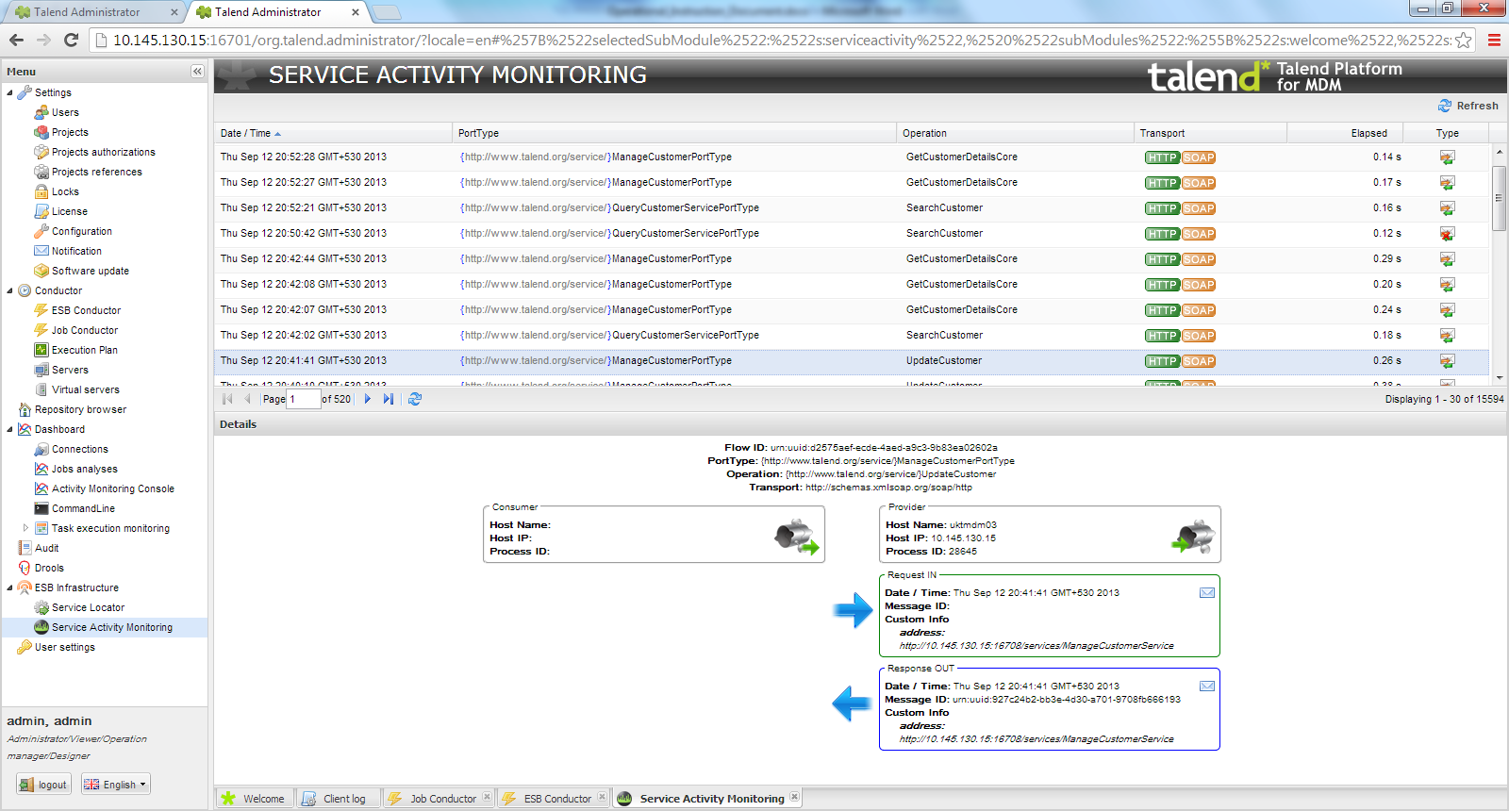

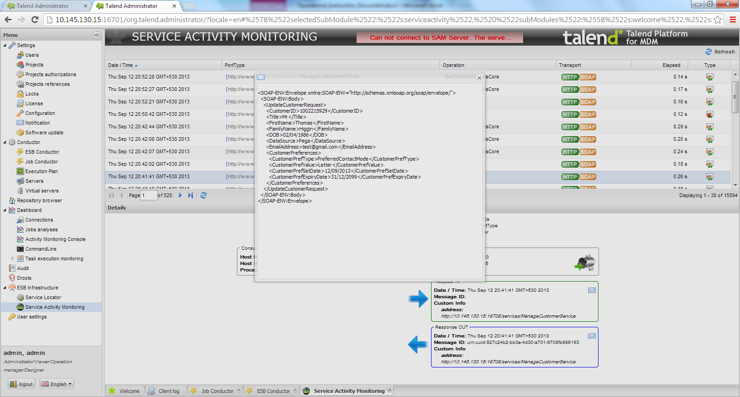

## Housekeeping Policies

MDM services actual request and response messages will be logged in Talend Administrator Console (ESB Job Conductor) using Service Activity Monitoring (SAM) feature. This will be used during Integration Testing / UAT to debug the messages. However, in production it can be switched off if any implications on system’s performance or response time.

Housekeeping script/job need to be created to maintain only **last “*7”* days** and records older than configured days should be purged from following SAM database tables (EVENTS_CUSTOMINFO and EVENTS).

# Appendix

## References

## Ensura – Business Rules Presentation:

[https://serveusa.sharepoint.com/sites/HomeServe/GlobalResources/GlobalProjects/Ensura/Programme%20Documentation/Unity_MDM_Release_Business_Rules.pptx?d=w6cbd9861090046a5a39b808a009ccb0f&Source=https%3A%2F%2Fserveusa%2Esharepoint%2Ecom%2Fsites%2FHomeServe%2FGlobalResources%2FGlobalProjects%2FEnsura%2FPages%2FDataMigrationMasterList%2D%2Easpx%23InplviewHash4ff4f34c%2D129f%2D44ef%2Da843%2D01400633ce24%3DFilterFields1%253DSub%25255Fx002d%25255FCategory%2DFilterValues1%253DBRD%25253B%252523Business%252520Rules](https://serveusa.sharepoint.com/sites/HomeServe/GlobalResources/GlobalProjects/Ensura/Archive%20%20documents/MDM/Requirement/Unity_MDM_Release_Business_Rules.pptx?d=w6cbd9861090046a5a39b808a009ccb0f&Source=https://serveusa.sharepoint.com/sites/HomeServe/GlobalResources/GlobalProjects/Ensura/Pages/DataMigrationMasterList-.aspx#InplviewHash4ff4f34c-129f-44ef-a843-01400633ce24=FilterFields1%3DSub%255Fx002d%255FCategory-FilterValues1%3DBRD%253B%2523Business%2520Rules)

## Real time Interface Contract Document (ICD)

<https://serveusa.sharepoint.com/sites/HomeServe/GlobalResources/GlobalProjects/Ensura/Programme%20Documentation/R6_Sprint4_INT3233_MDM_ManagePartyService_ICD.docx?d=we4e1cf9ac1274c81a38d62417079dba2>

## MDM Platform Design

[https://serveusa.sharepoint.com/sites/HomeServe/GlobalResources/GlobalProjects/Ensura/_layouts/15/WopiFrame.aspx?sourcedoc={E76D6696-3E15-4DDB-AD59-B121D96DA560}&file=Unity_MDM_Platform_Introduction.pptx&action=default](https://serveusa.sharepoint.com/sites/HomeServe/GlobalResources/GlobalProjects/Ensura/_layouts/15/WopiFrame.aspx?sourcedoc=%7bE76D6696-3E15-4DDB-AD59-B121D96DA560%7d&file=Unity_MDM_Platform_Introduction.pptx&action=default)

## Reference Dataset

**Unity Metadata Catalogue:**

[https://serveusa.sharepoint.com/sites/HomeServe/GlobalResources/GlobalProjects/Ensura/_layouts/15/WopiFrame.aspx?sourcedoc={F9916697-43F7-4C99-8DFC-523A7AD19D3D}&file=Unity%20Metadata%20Catalogue.xlsx&action=default](https://serveusa.sharepoint.com/sites/HomeServe/GlobalResources/GlobalProjects/Ensura/_layouts/15/WopiFrame.aspx?sourcedoc=%7bF9916697-43F7-4C99-8DFC-523A7AD19D3D%7d&file=Unity%20Metadata%20Catalogue.xlsx&action=default)

## Unity Error Catalogue:

<https://serveusa.sharepoint.com/sites/HomeServe/GlobalResources/GlobalProjects/Ensura/Archive%20%20documents/A%26D%20(archived%20documents)/Unity%20Error%20Catalogue.xlsx?d=wcb592cf811594741b2a836165f0480bc>

## Ensura Duplicate Customer Check Requirement Document

[https://serveusa.sharepoint.com/sites/HomeServe/GlobalResources/GlobalProjects/Ensura/Programme%20Documentation/INT21_MDM_DuplicateCustomerCheck_ICD.docx?d=w2c51b2c8a33f4a54afbcf153de86a343](https://serveusa.sharepoint.com/sites/HomeServe/GlobalResources/GlobalProjects/Ensura/Programme%20Documentation/MDM_DupCustCheck_ICD_MDM_Release.docx?d=w2c51b2c8a33f4a54afbcf153de86a343)

## Pega Business Rules for R1

Refer below sharepoint links for latest Pega data dictionaries, data validation and business rules.

[https://serveusa.sharepoint.com/sites/HomeServe/GlobalResources/GlobalProjects/Ensura/_layouts/15/WopiFrame.aspx?sourcedoc={CF044467-3B60-46ED-A87C-01B675DB17D8}&file=CSS1_InboundCallHandling_DCO_Specifications.doc&action=default](https://serveusa.sharepoint.com/sites/HomeServe/GlobalResources/GlobalProjects/Ensura/_layouts/15/WopiFrame.aspx?sourcedoc=%7bCF044467-3B60-46ED-A87C-01B675DB17D8%7d&file=CSS1_InboundCallHandling_DCO_Specifications.doc&action=default)

[https://serveusa.sharepoint.com/sites/HomeServe/GlobalResources/GlobalProjects/Ensura/_layouts/15/WopiFrame.aspx?sourcedoc={6E26B775-306E-4C90-BBC9-694E8B4FFF29}&file=CSS4_Enrolment_DCO%20Specification.doc&action=default](https://serveusa.sharepoint.com/sites/HomeServe/GlobalResources/GlobalProjects/Ensura/_layouts/15/WopiFrame.aspx?sourcedoc=%7b6E26B775-306E-4C90-BBC9-694E8B4FFF29%7d&file=CSS4_Enrolment_DCO%20Specification.doc&action=default)

[https://serveusa.sharepoint.com/sites/HomeServe/GlobalResources/GlobalProjects/Ensura/_layouts/15/WopiFrame.aspx?sourcedoc={2C9696FB-022F-4465-83C5-C2680B878009}&file=CSS8_UpdateCustomerProfile_DCO_Specifications.doc&action=default](https://serveusa.sharepoint.com/sites/HomeServe/GlobalResources/GlobalProjects/Ensura/_layouts/15/WopiFrame.aspx?sourcedoc=%7b2C9696FB-022F-4465-83C5-C2680B878009%7d&file=CSS8_UpdateCustomerProfile_DCO_Specifications.doc&action=default)

## Duplicate Cover Check Design Document

<https://serveusa.sharepoint.com/sites/HomeServe/GlobalResources/GlobalProjects/Ensura/Programme%20Documentation/R6_Sprint2_INT25_MDM_DuplicateCoverCheck_IDD.docx?d=wcc8d40df66a944309e9446a6b2994f4f>

## Ensura – INT32,33 Small Change Document (BRD) for Release 4



## Review Comments



## BBDM CR241 related artifacts

**CR requirement:**



**LOVs for Migration Markers:**



**Design discussion email – CR241:**



**Email from Karthic (Ensura team) on CR241 discussion:**



**Email from Mark to include MDMAddressID in GetParty response:**



## CR 305 Details

